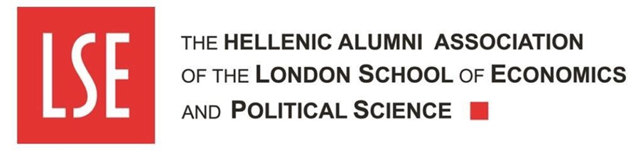

Press release
Athens, 16th March 2021.

HAALSE: Live Webinar on 30th March called "ESG in the time of COVID-19"
The Hellenic Alumni Association of London School of Economics and Political Sciences (HAALSE) explores how Environmental Social and Governance (ESG) criteria will reshape the post-pandemic investment landscape and the marketplace as a whole

What will the investment landscape look like after COVID-19? What will drive the marketplace, businesses and investors? The future of investments and businesses, as influenced by ESG factors and the Sustainable Development Goals, is the topic of the online discussion that HAALSE will be hosting on Tuesday, March 30th 2021 from 18.30 to 20.00 on YouTube and Facebook Live.
The coronavirus pandemic, the so-called first "sustainability crisis" of the 21st century, has pulled forward ESG trends by years in a matter of months, leading to unprecedented changes in the way businesses, investors and the marketplace operate as a whole. As the pandemic has amplified the social impact of businesses, demonstrating that they are not just economic units solely pursuing the highest profit, the use of purely financial metrics to assess their performance may be particularly problematic. Concepts such as “green growth”, “circular economy”, respect of human rights, protection of stakeholders' interests, inclusion and diversity reveal data that traditional financial analysis does not usually capture, speaking to the sustainability of a business in its broadest sense. As a result, ESG factors increasingly approach the importance of the traditional financial metrics for investors.
HAALSE invites representatives of the political, business and academic world to discuss the growing impact of ESG and what will the post-pandemic landscape look like for businesses, investors and the society both in Greece and globally. The speakers at the webinar will be:

- H.E. Mr. Yannis Tsakiris, Deputy Minister of Development and Investments;
- Ms. Maria Alexiou, Chair of CSR Hellas and member of the BoD, CSR Europe;
- Ms. Lilian Nektariou, Franchise Country Director Greece, Cyprus, Malta, Coca-Cola Hellas;
- Mr. Mark Hempstead, Head of Alternative Investments for Europe, the Middle East and Africa, J.P. Morgan Wealth Management (London);
- Ms. Chloe Laskaridis, Senior member of the BoD, Lampsa Hellenic hotels S.A. and Member of the Board, ACLCF; and
- Dr. Ioannis Ioannou, Associate Professor of Strategy and Entrepreneurship, London Business School.
The discussion will be moderated by Ms. Izabella M. Tsirba, Finance and Capital Markets Lawyer and Legal Advisor, Engagement and Fundraising Officer of HAALSE.
Dr. Vassilis G. Apostolopoulos, Chairman of HAALSE, CEO of Athens Medical Group and Chairman of the Hellenic Association of Entrepreneurs will deliver a short welcome speech.
The webinar will be held in English and it will be open to the public upon registration at https://lse-alumni.gr/el/live-webinar-esg-in-the-time-of-covid-19/ . During the discussion it will be possible to submit your questions to the panel by sending an email at events@lse-alumni.gr
The webinar is supported by: the Hellenic Association of Entrepreneurs (Strategic Partner), CSR Hellas (Communication Consultant), V + O Communication (Communication Supporter), the Ecali Club, Coca Cola Hellas, Athens Medical Group, the Hellenic Bankers Association UK, Envolve Entrepreneurship, A. C. Laskaridis Charitable Foundation, 3K Investment Partners. Sponsors of the event are Interamerican and the John S. Latsis Public Benefit Foundation. Media Sponsors are the newspapers KATHIMERINI and The New York Times International Edition - Kathimerini English Edition.

END
For more information, please contact:
• Katerina Pournaropoulou Head of Communication, Sustainability and Excellence at aikpourna@gmail.com or on +306932618006.
• Isabella M. Tsirba, Legal Adviser, Engagement and Fundraising Officer, via tsirba_izabella@yahoo.gr or on +306951921083.
_____________________________________________________________________________
About HAALSE
The Hellenic Alumni Association of LSE (HAALSE) was founded in 1980 and its aim is to serve as the meeting point and voice of the historic University’s alumni in Greece contributing further to the networking of its members.
Since then, it has grown considerably, becoming one of the most active alumni association of foreign universities in Greece, displaying a significant increase in the number of registered members and intense activity in organizing events with the participation of key figures from the political, business, and academia in Greece and internationally.
* Since 2021, the Hellenic Alumni Association London School of Economics and Political Sciences has pledged to "No More Manels | No More Men", an initiative by Women Act that aims at equal representation of men and women in conference and event panels.

